March 5, 2025

The Honorable Joni Ernst
Chair, Senate Committee on Small Business and Entrepreneurship
United States Senate
260 Russell Senate Office Building
Washington, D.C. 20510

The Honorable Ed Markey
Ranking Member, Senate Committee on Small Business and Entrepreneurship
United States Senate
255 Dirksen Senate Office Building
Washington, D.C. 20510

Dear Chair Ernst and Ranking Member Markey,

I’m writing in support of your proposal to reform and reauthorize the Small Business Innovation Research and Small Business Technology Transfer (SBIR-STTR) programs as part of the INNOVATE Act. Expanding the reach of these programs to more innovators across the country is critical to our nation’s competitiveness and to Iowa’s economic growth.

Over time, Iowa has worked to lay the groundwork for a vibrant economy by investing in industries that are ripe for growth here – specifically, the biosciences, manufacturing, insurance and financial services. Our state rewards innovation because it’s the common thread that enables these key industry sectors to continue to scale wealth. As a result, Iowa has nurtured an entrepreneur ecosystem that is thriving. The SBIR-STTR programs play a critical role in Iowa’s efforts by supporting entrepreneurs who build emerging technologies. We’re proud that Iowa received 97 awards worth $55.8 million in the four-year period that ended June 30, 2023, and our current success rate of 26% is double the national average.

However, the SBIR-STTR programs aren’t realizing their full potential in helping companies nationwide compete for funding. Many smaller companies and rural startups that would benefit most from the programs lack the resources or expertise to navigate the SBIR-STTR solicitation process. As a result, most awards benefit companies in coastal metropolitan areas.

I appreciate that the INNOVATE Act makes fundamental changes to encourage more participation, including appropriate standards for the size of participating companies and Phase II awards for entrepreneurs transitioning into the workforce from academia. Also, the proposal to create Phase 1A awards with a shorter, streamlined application will attract thousands of new small business owners and entrepreneurs, both urban and rural, who may have been discouraged previously by bureaucratic red tape.

I love to think of the potential for our Iowa entrepreneurs who are building innovative ideas in their garages, machine shops or labs. Thank you for your efforts, consideration and continued support of Iowa.

Sincerely,
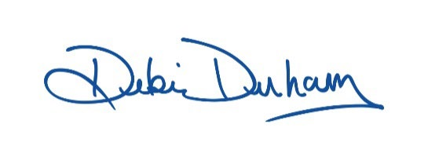
Debi Durham
Director

